1. Open MIT App Inventor and Create new project for MagicBall
2. Design and set the blocks

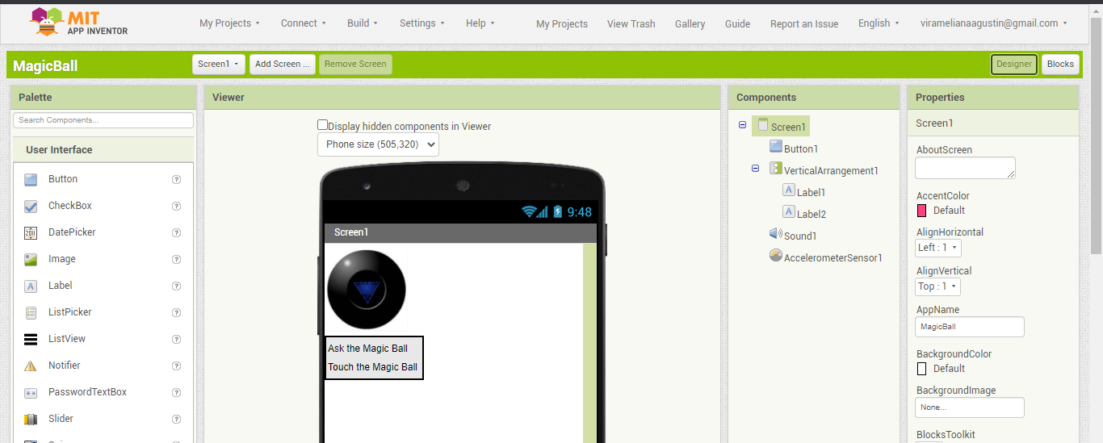

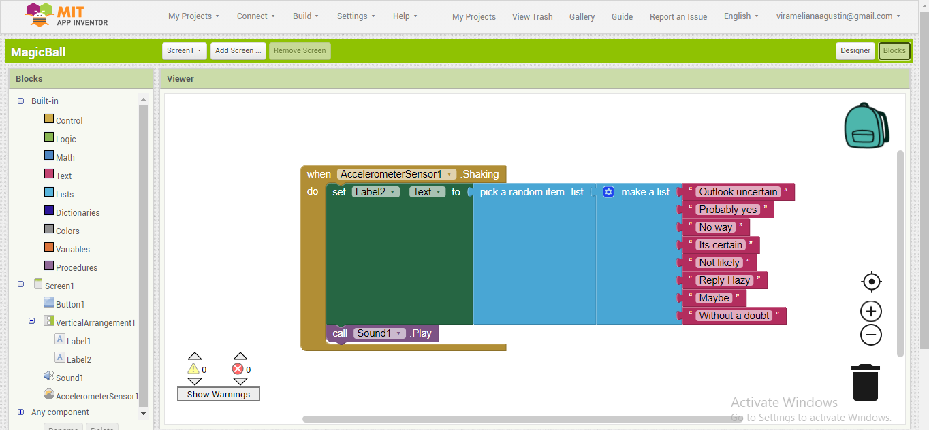

1. Try to run with AI Companion

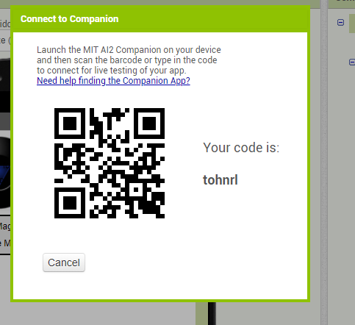

Connect with smartphone using MIT App Inventor

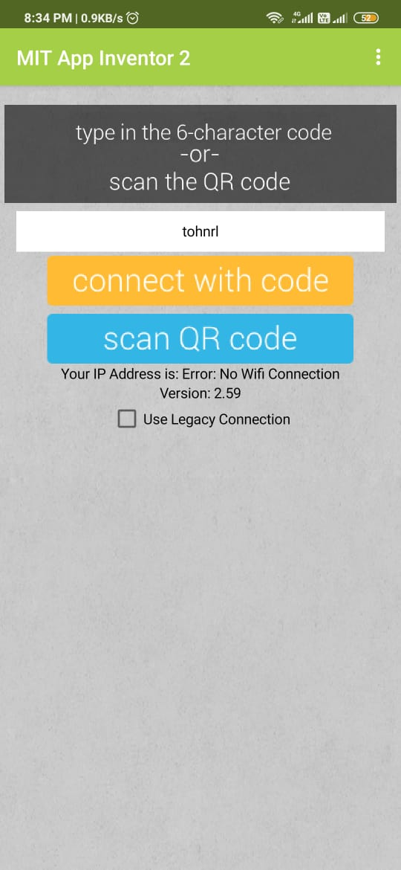

After its connect, wait the progress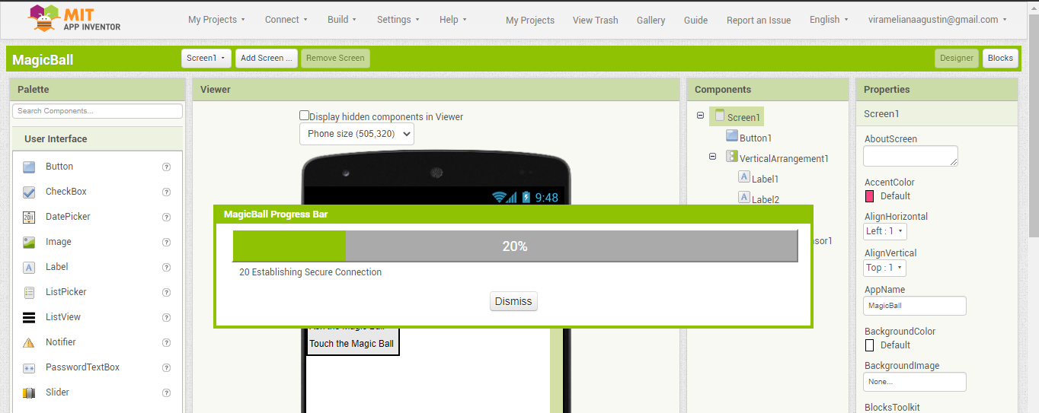

1. Check the result (it will change the suggestion when shaking the phone)



1. Check the gallery, it will have an assets from the application

